Develop The Web Application Using Node-RED

Aim: Develop the web application using Node-RED Steps Followed:

* 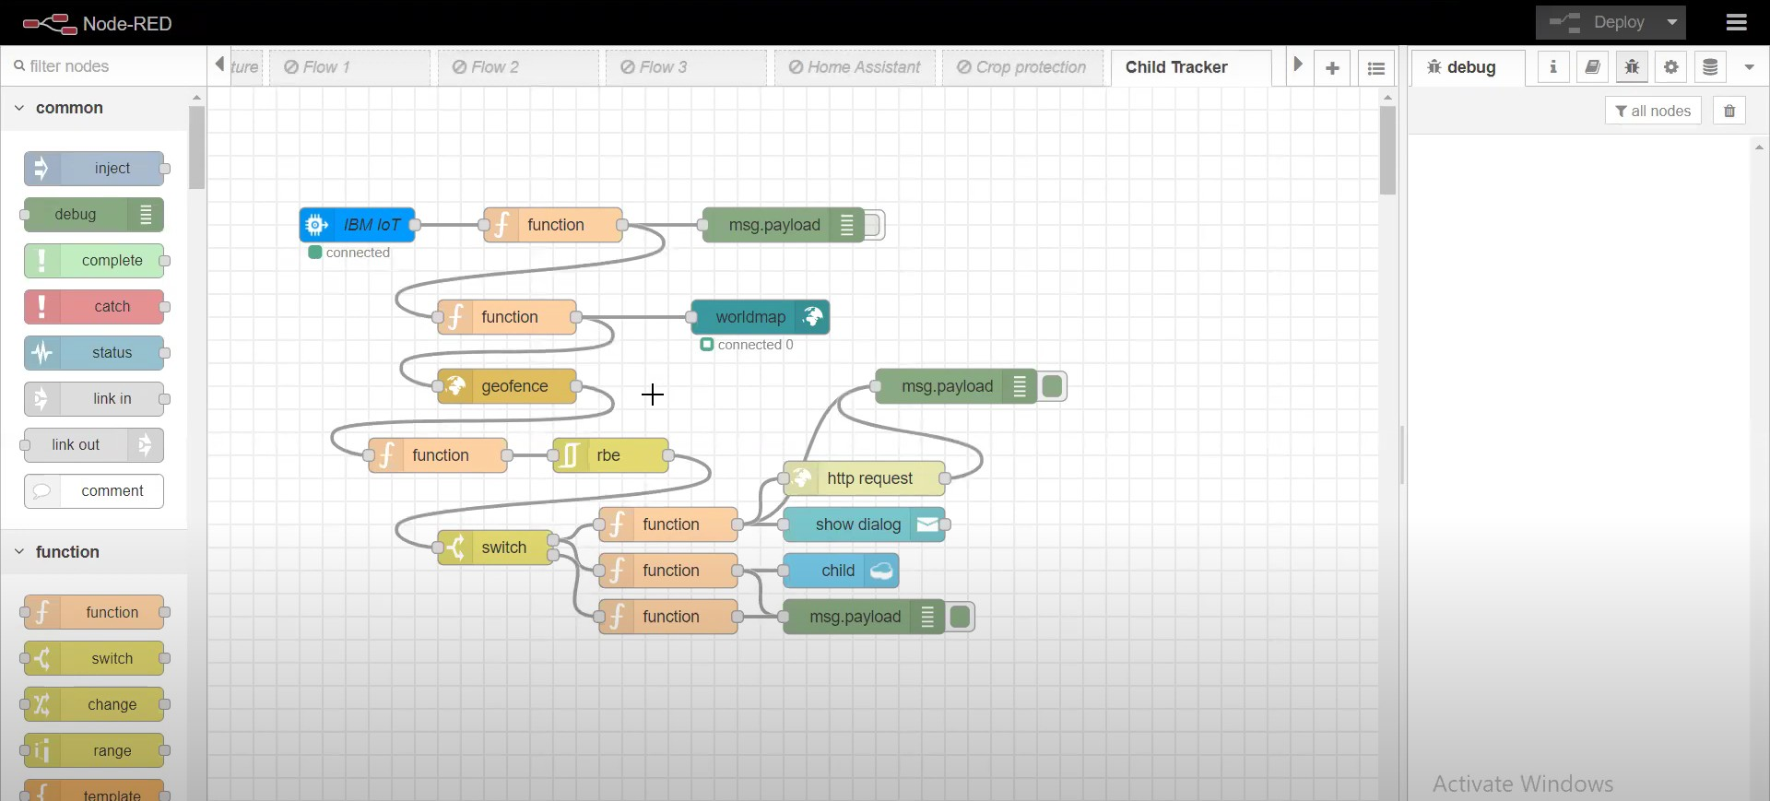Opened a Node-RED project
* Added code to get child location in python

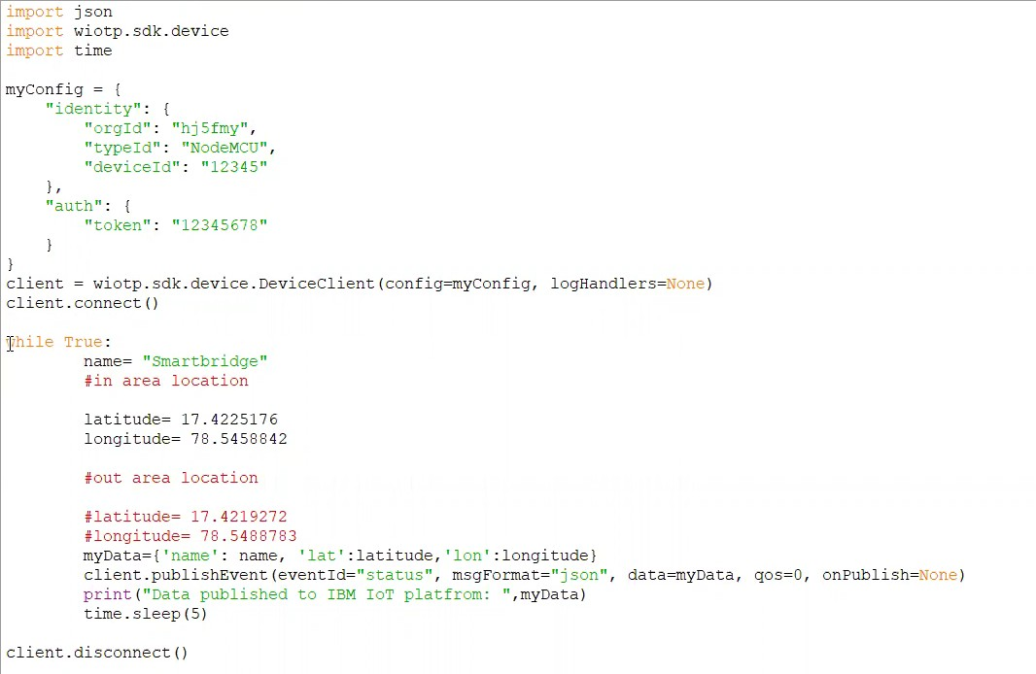

* 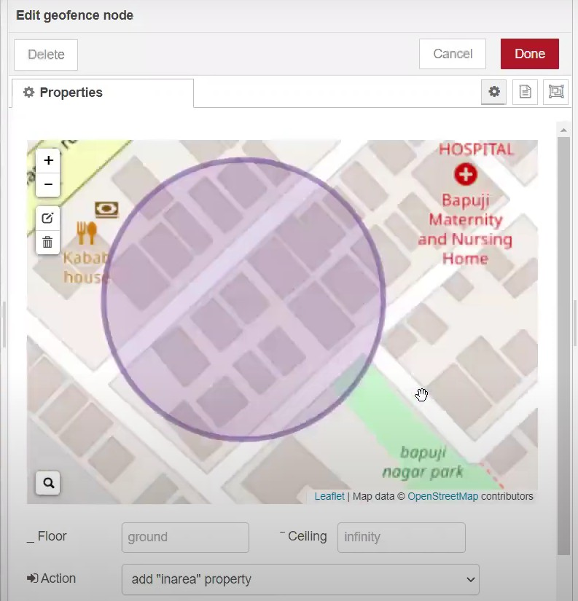Created the GeoFence
* 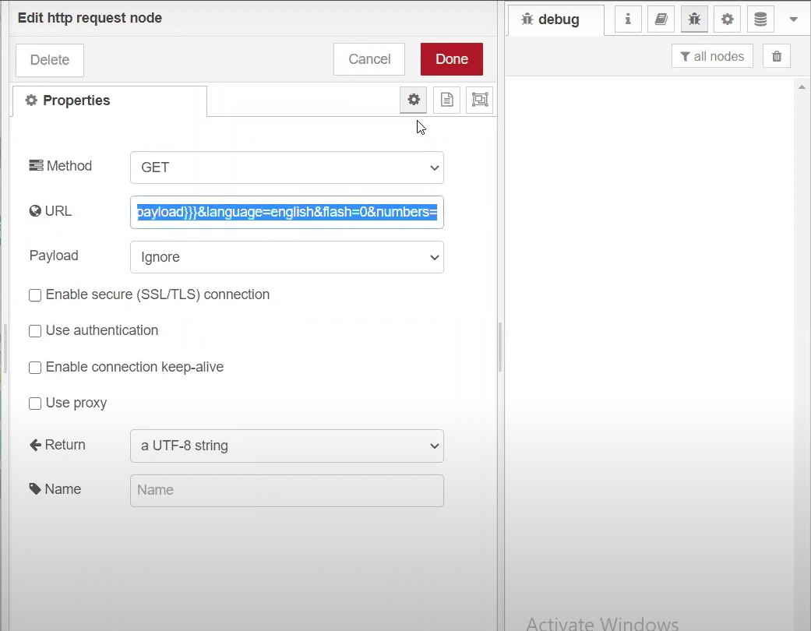Editing the HTTP Request URL
* Located the child

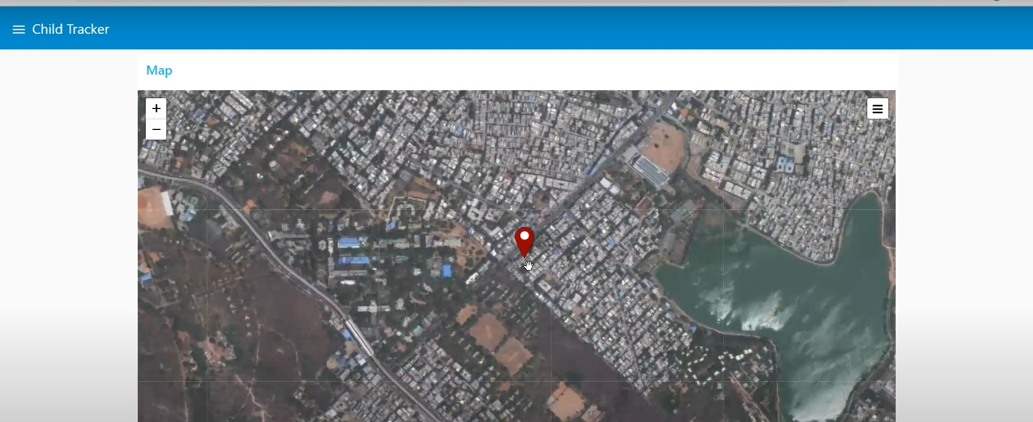

* 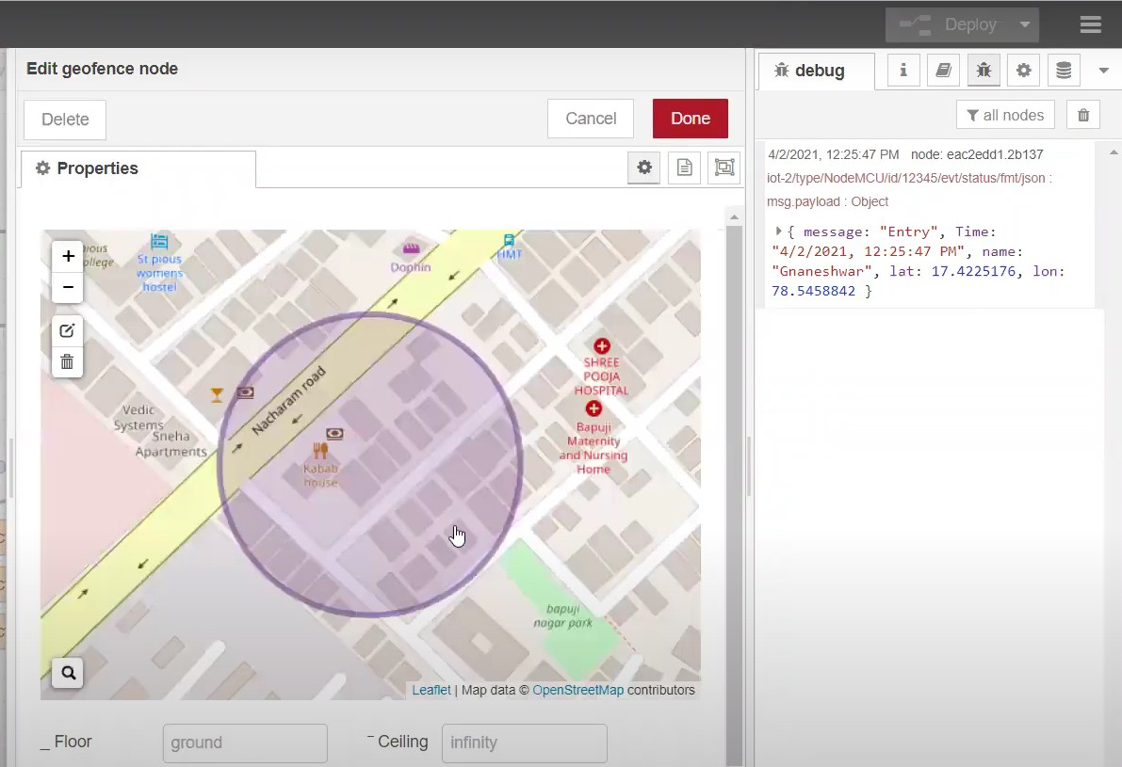Created the geofence node
* Python script sending requests to IBM Cloud

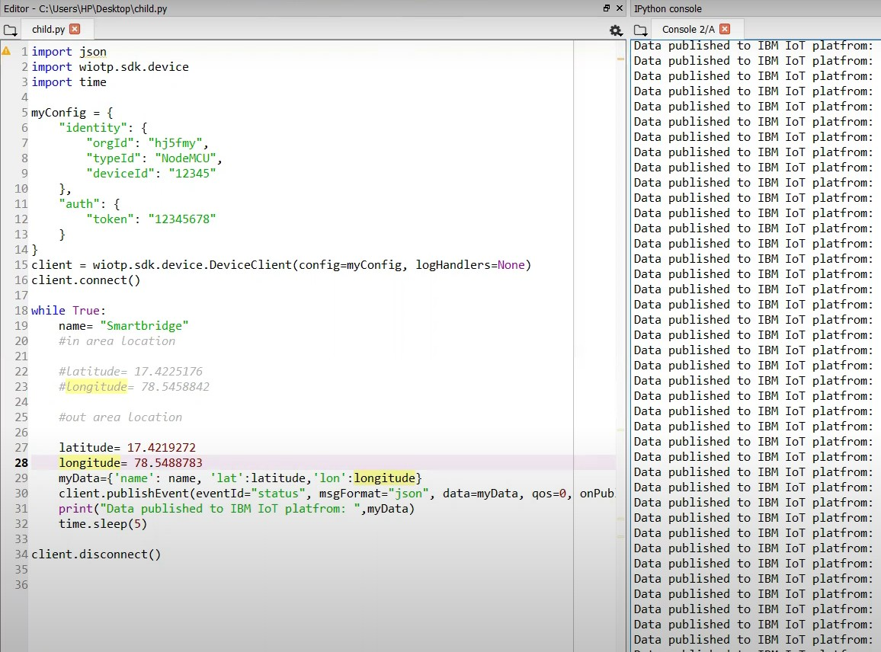

* 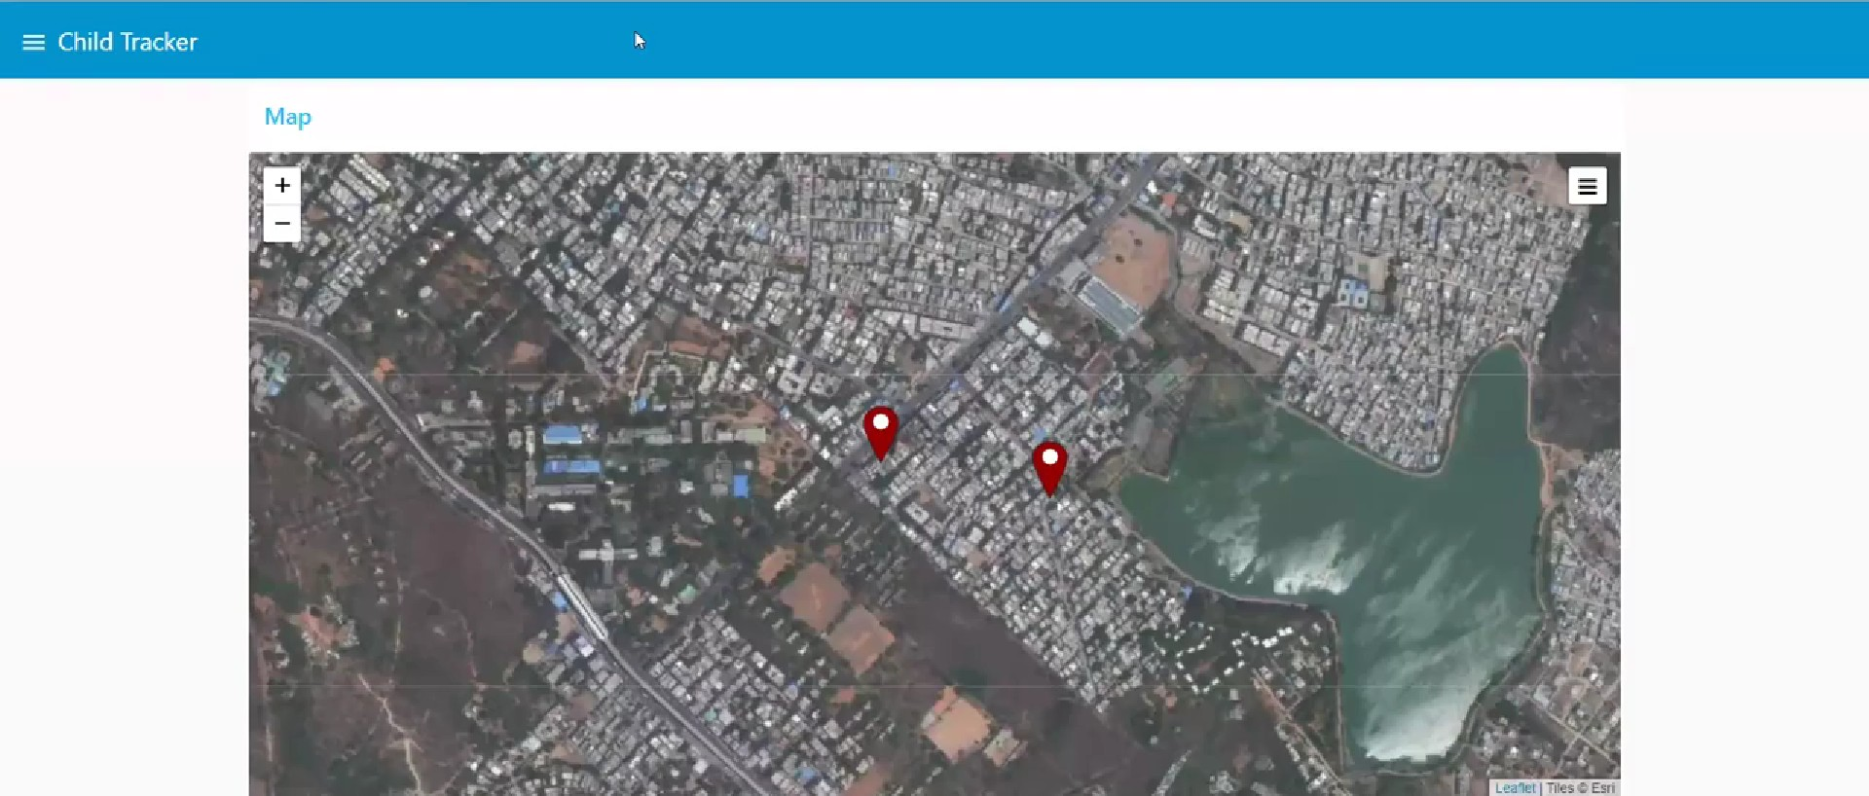After running the script, the web UI shows “Person is not in the particular area”

Result: Successfully developed the web application using Node-RED